VOLUNTEER ONBOARDING

Name - The Club is registered with the Cheshire County FA as Upton Junior Football Club (Chester).

Status - Registered Charity Number 1172690

- New Volunteers

The club has 3 levels of Volunteers: Coaches, Assistant Coaches and First Aiders, all are required to complete a CRC check. Please note that no volunteers can be involved in any way until their CRC has been approved.
- Coaches will need to complete an FA Level 1 course
- Assistant Coaches will need to complete, an FA Emergency Aid and Safeguarding Courses
- First Aiders will need to complete an FA Emergency Aid Course

All volunteers must read the Club policies as published on the Upton JFC website.
All new volunteers joining Upton JFC should be referred to a Club Welfare Officer by an existing coach.
The referring coach must have discussed expectations with the new coach and be confident that they will uphold the standards expected of Upton JFC volunteers.
Once this contact has been established, the following information should be sent to the CWO:
- Name
- Email and home address
- Mobile number
- Date of Birth
- Name and details of age group and team

The new volunteer must then get an FA number and complete a Criminal Records Check (CRC).
- To obtain a FAN, log in via the following: https://secure.thefa.com/FAN/Register.aspx

- To start the CRC process, go to the following website and select Register (do not attempt to log in) https://gbg.onlinedisclosures.co.uk/Authentication/Login?ReturnUrl=%2fLanding%2fLandingPage

You will need the following information:
- Club ID: 103993
- Secret Word: Boots

Once the CRC registration process has been completed, arrange to meet with one of the Club Welfare Officers. Please contact us at welfareuptonjfc@gmail.com to organise this.
At this meeting, you will need to bring the 3 documents you used to register, please note that any bank statements/utility bill must be less than 3 months old and all addresses on documents must match.
- First Aiders – Ideally each team will have at least one designated First Aider, in addition to the mandatory CRC validation, each volunteer must complete the 3 hour EFA course.

- Assistant Coaches – Where volunteers complete the FA Emergency First Aid Course and FA Safeguarding Children course, both courses are 3 hours long and all fees are paid by the club. These courses will, where possible, be arranged by the CWO, but there may be instances where these need to be booked directly with the FA. If this is the case, all fees will be reimbursed.

- Lead Coaches will need to complete the FA Level 1 coaching course. For each team the Club will fund at least 2 courses to ensure that there is an adequate level of coaching expertise. These courses have to be booked directly with Cheshire FA via the website. http://www.cheshirefa.com/coaches/development-and-courses.

Note: if these courses are booked the EFA and Safeguarding are not needed.

- FA Licensed Coaches - Coaches who have completed their Level 1 are strongly encouraged to become an FA Licensed Coach. Please help the club meet its target via the following link:
http://facc.thefa.com/Users/Account/LogOn?ReturnUrl=%2fnews
- Coaches are provided with the following kit:
  - Level 1 qualified coaches will receive a rain jacket, tracksuit pants and a training top
  - EFA and Safeguarding coaches will receive a rain jacket only.

All kit remains the property of the club and must be returned when the volunteer leaves the club.
- Existing Volunteers

Both EFA and Safeguarding courses and CRC checks must be renewed every 3 years.
- CRC - You will be contacted by the CWO within 2 months of your CRC expiring and you must complete the above process. However, a meeting is not always necessary, and, in some instances, documents can be sent via secure method to the CWO who will complete the verification.

Any coach who allows their CRC to lapse will be unable to continue coaching.

- EFA – a course must be attended and whilst every effort will be made to book courses for managers via the local league, it is the volunteer’s responsibility to ensure that this qualification does not lapse.

- Safeguarding – this can be completed online and must also be completed before the previous qualification lapses. Details of how to complete the online process are below.

- Go to the following website

http://www.cheshirefa.com/coaches/development-and-courses/fa-safeguarding-children-workshop
- Scroll to the bottom right and you will see the following:

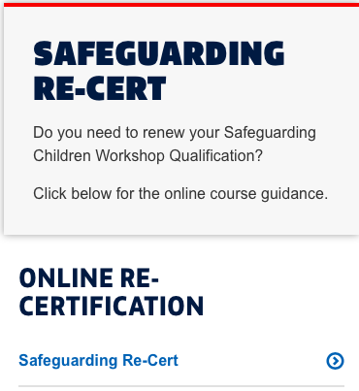

- Click on the link and follow the instructions.

- Please confirm to the CWO Team when this has been completed.

Reviewed and Updated: September 2018

